|  |  |  |  |  |  |  |  |  |  |  |  |
| --- | --- | --- | --- | --- | --- | --- | --- | --- | --- | --- | --- |
|  | | **Hope Foundation’s,**  **Finolex Academy of Management and Technology, Ratnagiri** | | | | | | | | | |
| **Department of Information Technology** | | | | | | | | | |
| Subject name: OLAP LAB | | | | | | | | Subject Code: ITL503 | | | |
| Class | | TE IT | | Semester – V (CBCGS) | | | | Academic year: 2018-19 | | | |
| Name of Student | | Kazi Jawwad A Rahim | | | | | **QUIZ Score :** | | | | |
| Roll No | | 32 | | | Assignment/Experiment No. | | | | | 02 | |
| Title**:**  **Study of Transaction Management in JDBC.** | | | | | | | | | | | |
|  | | | | | | | | | | | |
| 1. **Course objectives applicable:**   **LOB1**- Understand the stages and properties of transactions and the concepts involved with Serializability. | | | | | | | | | | | |
| 1. **Course outcomes applicable:**   **LO1**- Apply the advance concepts of transaction management and recovery techniques. | | | | | | | | | | | |
| **3. Learning Objectives:**   * To learn how to commit transaction using commit () method. * To learn how to rollback transaction using rollback () method . | | | | | | | | | | | |
| **4.Practical applications of the assignment/experiment:**   * Banking database application. | | | | | | | | | | | |
| **5. Prerequisites**: 1. Database Connectivity using JDBC.  2. Transaction Management Operations. | | | | | | | | | | | |
| **6. Hardware Requirements**:   1. PC with 4GB RAM, 500GB HDD,   **7. Software Requirements:**  1. Windows installed  2. Net Beans IDE  3. MySQL Command Line Client | | | | | | | | | | | |
|  | | | | | | | | | | | |
| **8. Quiz Questions (if any): (Online Exam will be taken separately batch wise, attach the certificate/ Marks obtained)**  https://goo.gl/6gS8j1 | | | | | | | | | | | |
|  | | | | | | | | | | | |
| **9. Experiment/Assignment Evaluation:** | | | | | | | | | | | |
| **Sr. No.** | **Parameters** | | | | | | | | **Marks obtained** | | **Out of** |
| **1** | Technical Understanding (Assessment may be done based on Q & A **or** any other relevant method.) Teacher should mention the other method used - | | | | | | | |  | | 6 |
| **2** | Neatness/presentation | | | | | | | |  | | 2 |
| **3** | Punctuality | | | | | | | |  | | 2 |
| **Date of performance (DOP)** | | |  | | | **Total marks obtained** | | |  | | **10** |
| **Date of checking (DOC)** | | |  | | | **Signature of teacher** | | | | | |

**Results:**

**Source Codes:**

**1. signupTM.html:**

**>> form tag portion:**

<form class="signup-page" name="signup" method="post" onsubmit="return validatep()" action="signupTM.jsp">

**>> button tag portion:**

<button class="btn btn-primary" type="submit"">Register</button>

**>> Javascript protion:**

<script type="text/javascript">

function validatep()

{

var ans;

ans=confirm("Do you want to commit?");

if(ans == true)

return true;

else

{

alert("Not saved!");

return false;

}

}

</script>

**2. signupTM.jsp:**

<%@page import="java.sql.*" language="java"%>

<%

try

{

Class.forName("com.mysql.jdbc.Driver");

Connection conn=DriverManager.getConnection("jdbc:mysql://localhost:3306/mentoring","root","");

conn.setAutoCommit(false);

String username=request.getParameter("username");

String email=request.getParameter("email");

String pswd=request.getParameter("pswd");

String category=request.getParameter("category");

PreparedStatement ppst=conn.prepareStatement("insert into login values(?,?,?,?)");

ppst.setString(1, username);

ppst.setString(2, pswd);

ppst.setString(3, email);

ppst.setString(4, category);

int rows=ppst.executeUpdate();

if(rows==1)

{

conn.commit();

response.sendRedirect("ssuccess.html");

}

else

{

out.println("Couldn't save!");

conn.rollback();

}

}

catch(Exception e){

out.println(e);

}

%>

**Output:**

**Case 1: Committed transaction**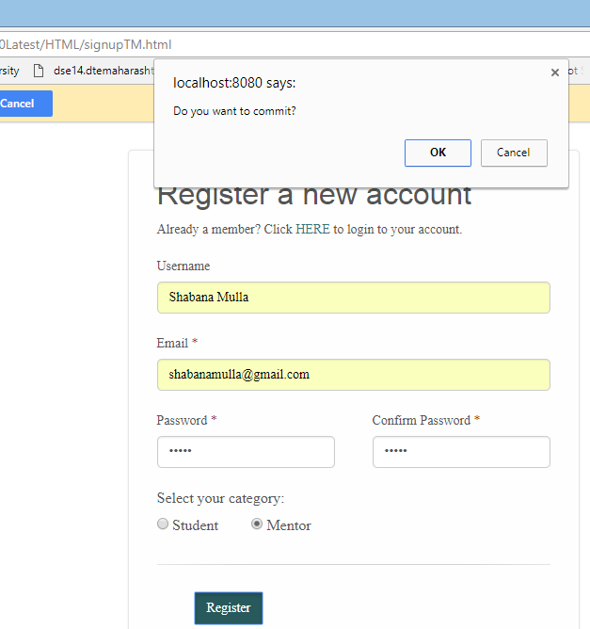

**By clicking "ok", we get...**

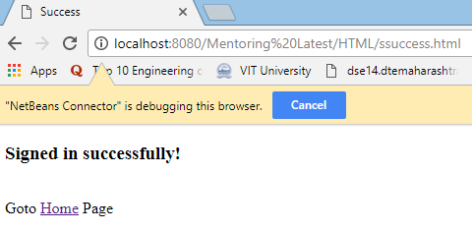

**Database state:**

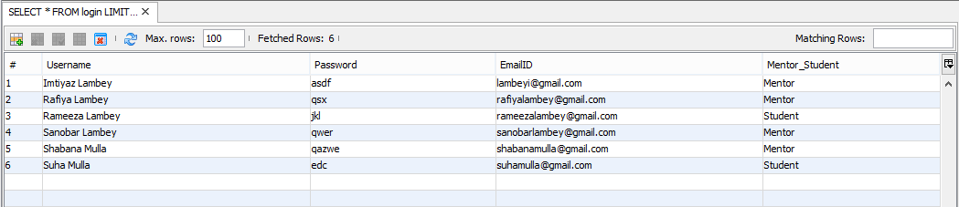

**Case 2: Rollbacked transaction**

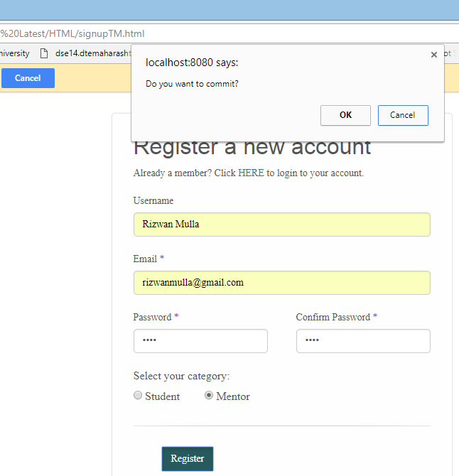

**By clicking "cancel"...**

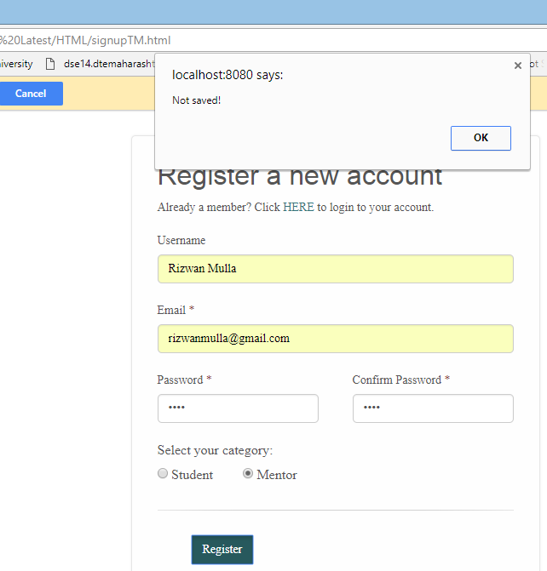

**Database State:**

